# EDUCATION

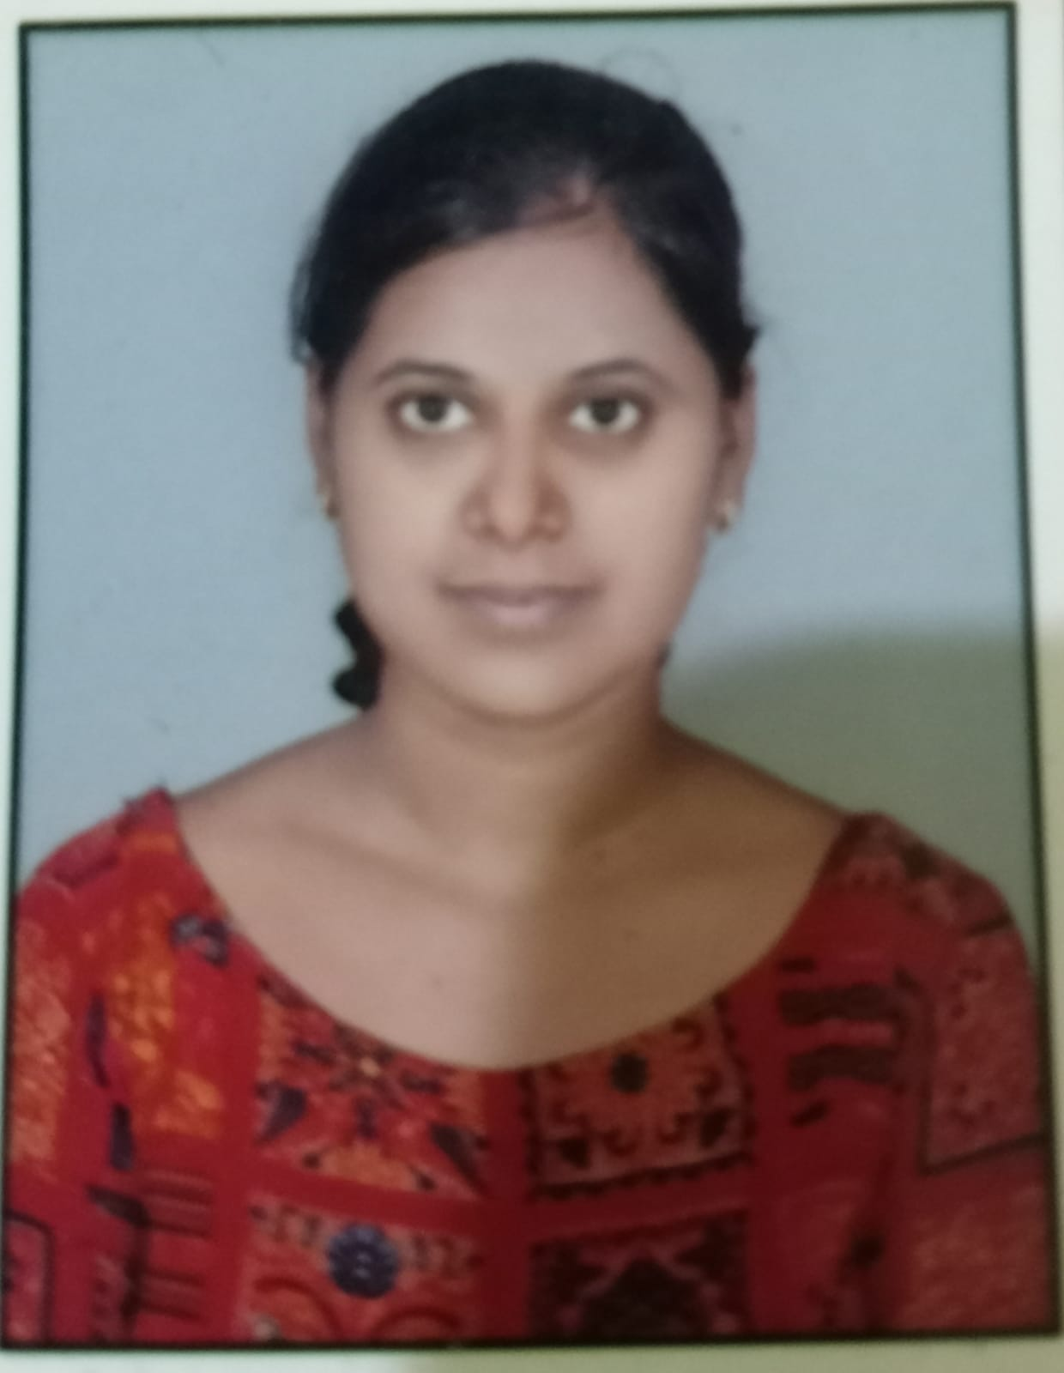

Trupti Gaurkar

Fresh Graduate

To Obtain a Challenging position that best utilizes my skill and provide opportunities to grow my technical and managerial skill which would enable me as a fresh graduate to grow while fulfilling organization goal

truptigaurkar1999@gmail.com

7058905544

Chandrapur Maharashtra, India

linkedin.com/in/Trupti Gaurkar

[-](https://www.linkedin.com/in/prajakta-kotkar-944722250/)

github.com/Trupti Gaurkar

## MSc in Computer Science

Sardar Patel Mahavidyalaya Chandrapur

*6/2021 - 05/2023*,

*Courses*

Computer Science

## BSc in PMCs

Sardar Patel Mahavidyalaya, Chandrapur

Maharashtra

*06/2017 - 05/2021*,  *7.12 CGPA*

## Higher Secondary Education

Lokmanya Tilak Mahavidyalaya, Chandrapur

*06/2015 - 05/2017*,  *53%*

**Secondary Education**

Lokmanya Tilak Kanya Vidyalaya, Chandrapur

*06/2014 - 05/2015*,  *63%*

# PERSONAL PROJECTS

Distribution of project in Software Company

(03/2022 - 05/2023)

using ASP.NET, HTML and CSS

# SKILLS

Team Work

Time management

Ambition

# ACHIEVEMENTS

AVISHKAR-2023

*(POSTER COMPITATION “DIGITAL INDIA” -(2ND PRICE))*

POWER POINT PRESENTATION

*(IMPORTANT OF SOFT SKILL-(1ST PRICE))*

**TECHNICAL SKILLS**

Java , SQL , HTML , CSS, Advance Excel

# CERTIFICATES

C and C++ language Certificate (06/2016 - 05/2017)

# LANGUAGES

English Hindi

*Professional Working Professional Working*

*Proficiency Proficiency*

Marathi

*Native or Bilingual Proficiency*

# INTERESTS

Reading books

Dancing